Name:  Teacher : | ____________________________________  ______________________ |  | Date:_________
 | Year 12 Foundation  3D shapes investigation  Full working out MUST be shown to get full marks for each question.
Total Time: | 1 lesson | /20

3 dimension shapes can be made of a combination of various polygons. You can combine the same regular polygon to make a 3 dimensional shape, as seen below.
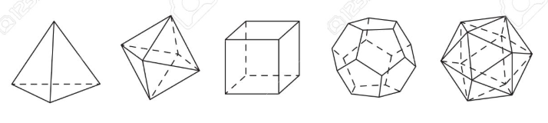

Where 2 dimensional shapes have lines and angles, 3 dimensional shapes have faces, edges and verticies.

Using isometric dot paper, draw 4 different 3 dimensional shapes. [ 2 marks]

After you have drawn your shapes, identify the total number of faces, edges and vertices in each of your drawn shapes.

Complete the table below with the names of each shape, and fill in the relevant data. [12 marks]

NAME | FACES | EDGES | VERTICIES
Is there a pattern if you added the number of faces and edges and added the vertices together? [1 mark]

Is there a pattern if you added the number of faces and edges, but took away the vertices? [1 mark]

Could you make a pattern by adding or subtracting the faces, edges and vertices from each other to get the same result each time? [2 mark]

Using the pattern you found above, write a formula that can be true for any 3 dimensional shape.[2 marks]

End of assessment.

